CS 255 System Design Document Template

This template lays out all the different sections that you need to complete for Project Two. Each section has guidance to prompt your thinking. You will need to continually reference the interview transcript as you work to make sure that you are addressing your client’s needs. There is no required length for the final document. Instead the goal is to complete each section based on what your client’s needs are. Remove this note when you are finished, and replace all bracketed text with the relevant information.

UML Diagrams

UML Use Case Diagram
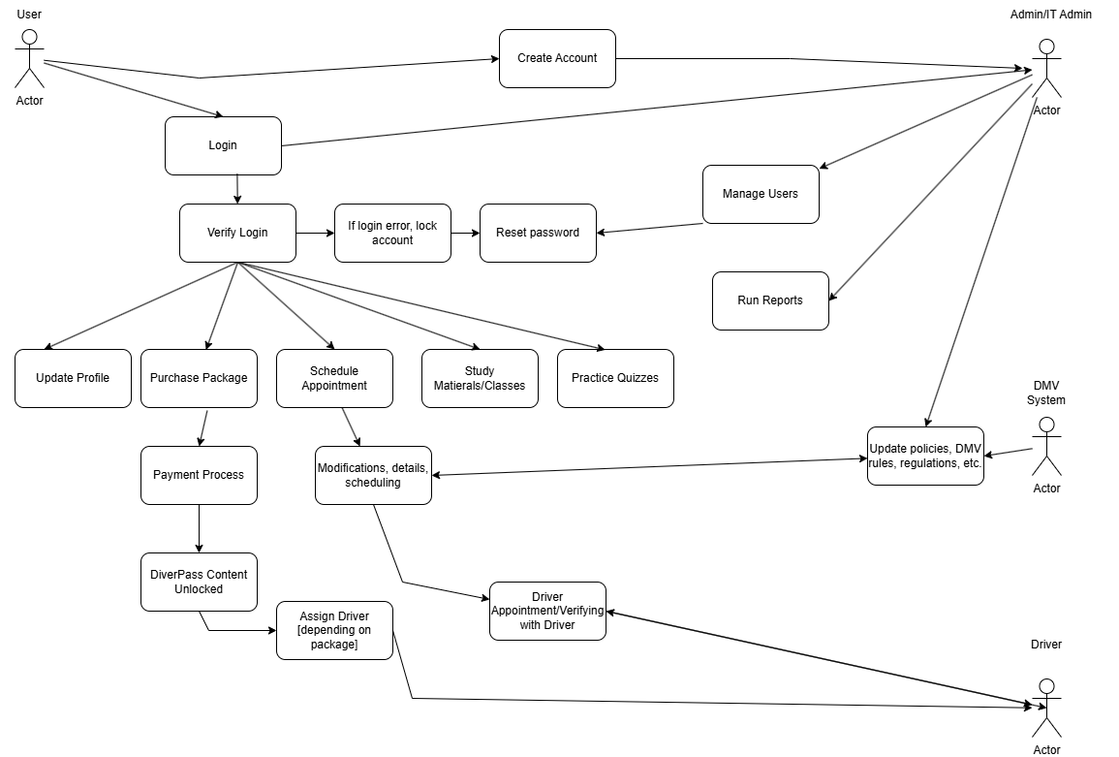

UML Activity Diagrams

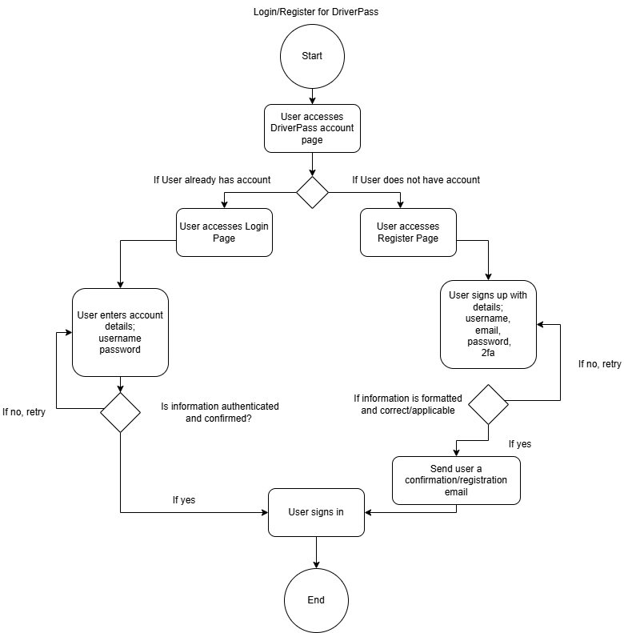
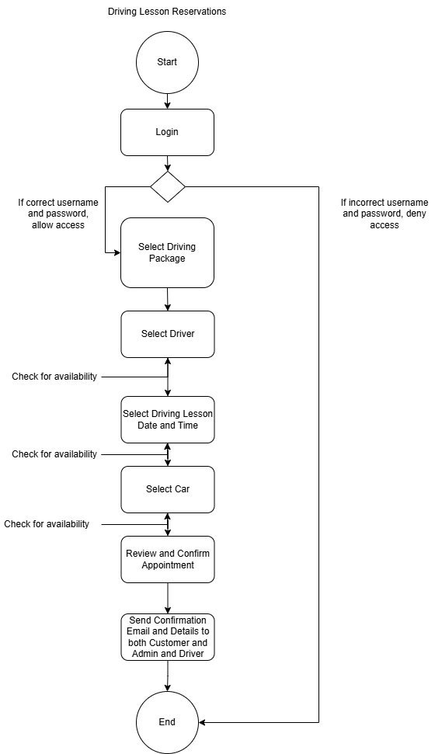

UML Sequence Diagram
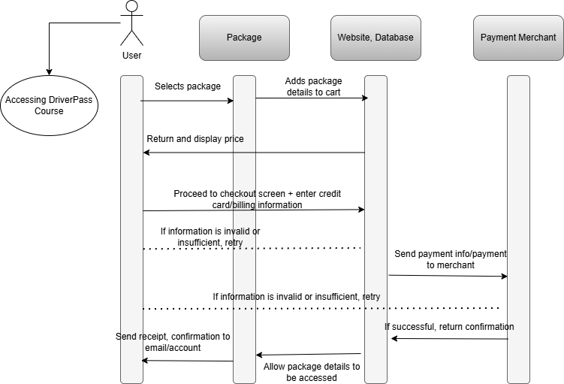

UML Class Diagram
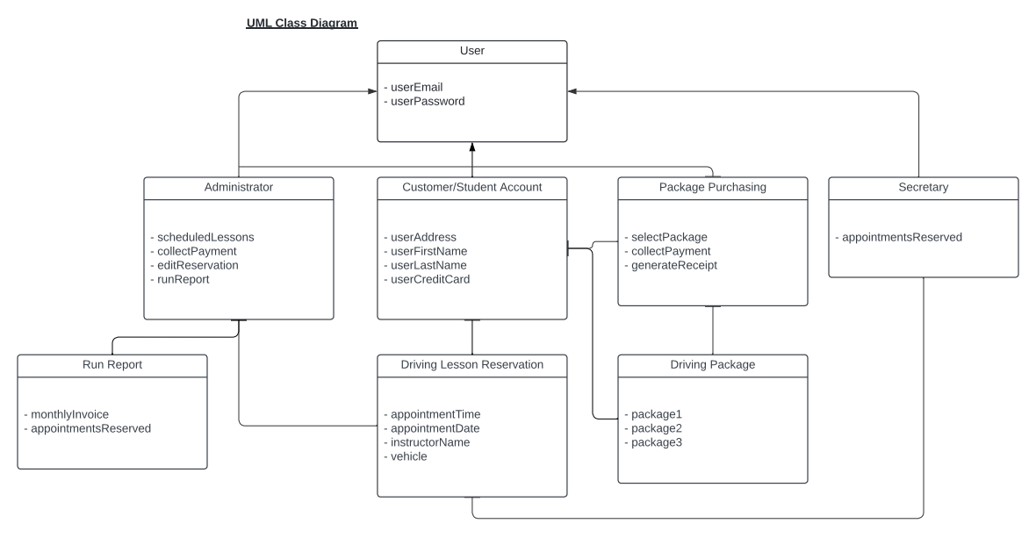

Technical Requirements
[Based on the diagrams you have created, describe the technical requirements of your system. These requirements should address the required hardware, software, tools, and infrastructure necessary for your system design.]
Due to the nature of the program and it being more entry-level and a smaller business, with the goal of wanting to expand and offer more services, we will definitely have to utilize cloud-based servers and applications for payment and data storage, of course with other requirements like backup and security software. Of course, to access the site, an internet connection, storage database, computer or device with Windows or alike OS to access the website, etc. are needed to use DrivePass in it’s full capacity. That way, full updates, access, and frequent accessibility is allowed.

